# EXPERIMENT-4

AIM : To create/perform relational set operations(i.e UNION

UNIONALL,INTERSECT,MINUS,CROSS JOIN,NATURAL ,

JOIN.)

Creating tables :

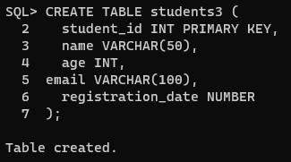

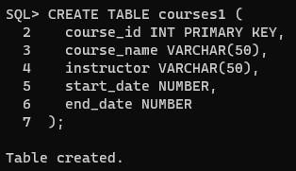

Inserting values into **personal_data** table :

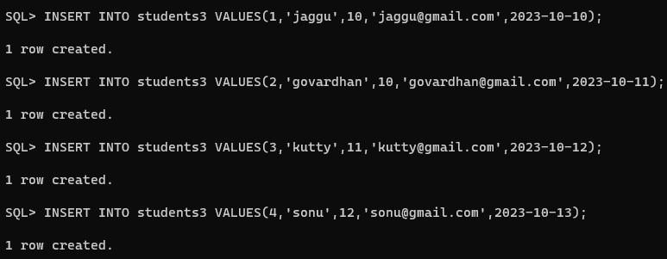

Inserting values into **information** table :

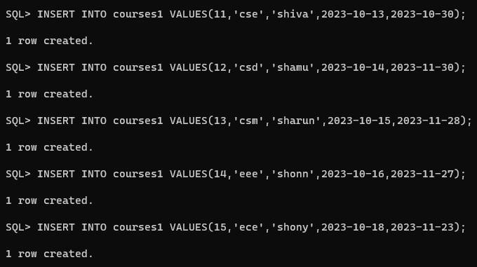

Union operation :

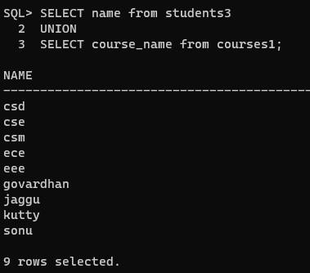

Union all operation :

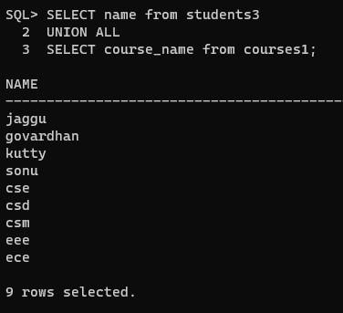

Intersect operation :

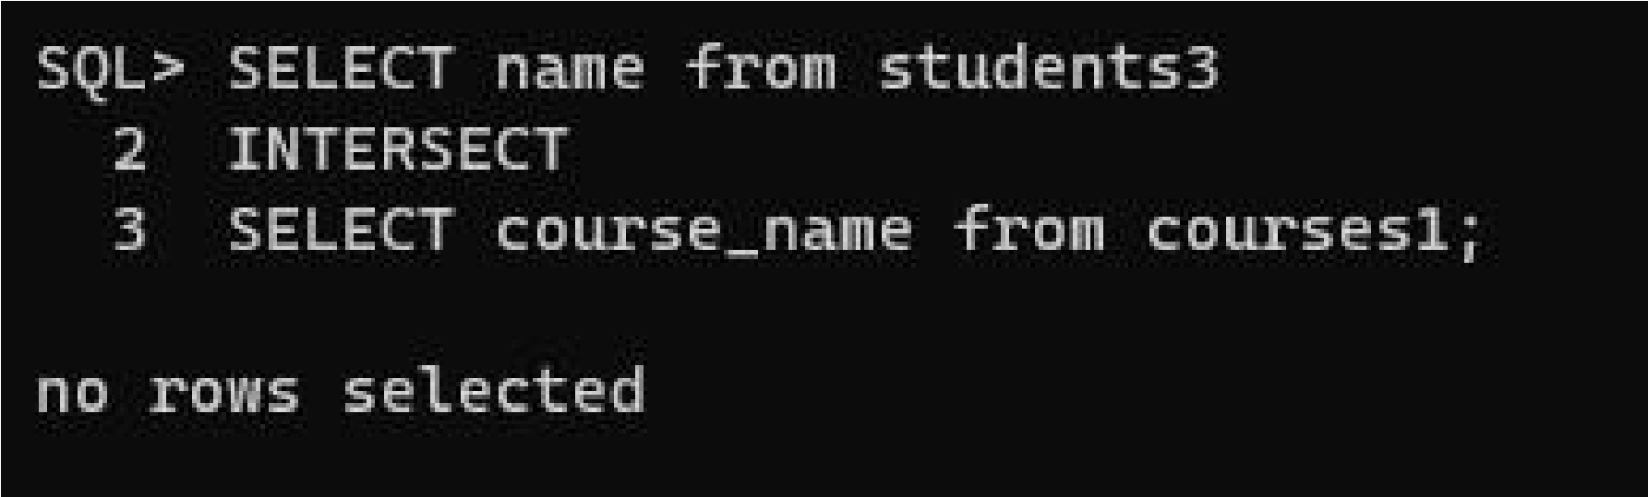

Minus operation :

